

VIRGINIA COMMONWEALTH UNIVERSITY

Statistical Analysis and Modelling (SCMA 632)

**A6 B: ARCH, GARCH, VAR, VECM**

**MSFT Shares from Yahoo Finance and Commodity Price Datasets**

**UJWAL P**

**V01107757**

**Date of Submission: 25-07-2024**

**GIT HUB Link of the assignment –**

**<https://github.com/UJWAL1529>**

**CONTENTS**

|  |  |  |
| --- | --- | --- |
| **Sl. No.** | **Title** | **Page No.** |
| **1.** | Introduction | **1** |
| **2.** | Results | **2** |
| **3.** | Recommendations | **14** |

# Introduction

Financial market analysis frequently involves examining the behavior of various asset classes, including stocks and commodities. eBay Inc. (EBAY), a leading e-commerce company, is an important player in the online marketplace sector. Its stock price movements are closely watched by investors and analysts due to its significant influence on the retail and technology industries. eBay's performance can offer insights into consumer behavior and broader economic trends, making it a key focus in financial market analysis.  
  
Commodity prices, such as those of gold, oil, and agricultural products, are equally important for comprehending market dynamics, as they are both influenced by and influence numerous economic factors. This analysis seeks to explore the volatility and interrelationships between EBAY stock prices and selected commodity prices by employing ARCH/GARCH models and VAR/VECM methodologies.

# Business Significance

**Risk Management:** Precise volatility forecasting aids in managing financial risk, such as optimizing portfolios, calculating Value-at-Risk (VaR), and developing effective hedging strategies.

**Investment Decisions:** Investors rely on volatility forecasts to make well-informed decisions regarding asset allocation, trade timing, and identifying high or low-risk periods.

**Policy Formulation:** Regulators and policymakers utilize these models to oversee financial stability and to design interventions during times of extreme market volatility.

# Methodology

**Data Collection:** Obtain historical financial data from sources such as Investing.com or Yahoo Finance.  
  
**Data Analysis:** Examine the time series data for ARCH/GARCH effects.

**Model Fitting:** Apply suitable ARCH/GARCH models to the data.  
  
**Forecasting:** Use the fitted models to forecast the three-month variability of the financial time series.

**VAR/VECM Analysis:** Conduct VAR/VECM analysis to explore the dynamic interactions between multiple financial time series.

# Datasets Used

Historical stock data of eBay (EBAY)   
Commodity prices

# Results

**Part A – GARCH and ARCH Model**

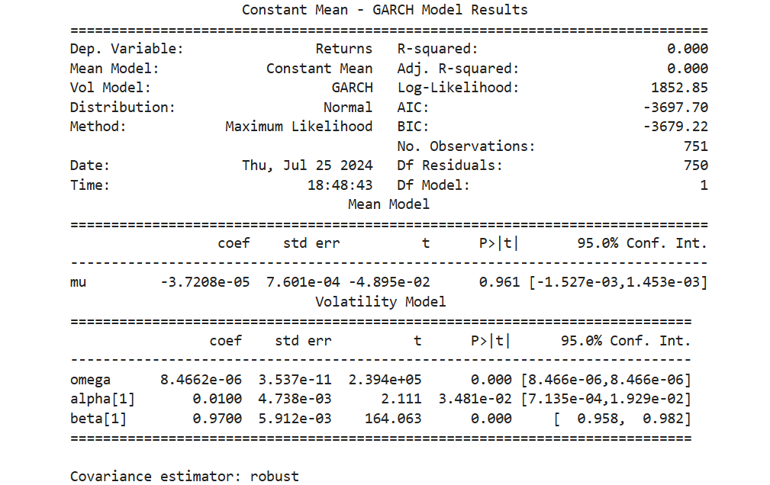

GARCH (Generalized Autoregressive Conditional Heteroskedasticity) model, which is widely used for modeling and forecasting time-series data, particularly financial returns. The key metrics from the output indicate that the dependent variable is Returns, with the mean model being a constant mean and the volatility modeled using GARCH. The model assumes a normal distribution and was estimated using the Maximum Likelihood method. The number of observations is 751, with 750 degrees of freedom for residuals.

In terms of model fit, the R-squared and adjusted R-squared values are both 0.000, indicating that the model explains very little of the variation in the returns. However, this is typical for models focused on volatility rather than mean returns. The log-likelihood value is 1852.85, while the AIC (Akaike Information Criterion) and BIC (Bayesian Information Criterion) are -3697.70 and -3679.22, respectively. These criteria are used to compare models, with lower values indicating a better fit.

The mean model results show that the estimated mean return (mu) is -3.7208e-05. This value is very close to zero, suggesting that the average return over the period is essentially zero. The t-value for mu is -0.04895, and the P-value is 0.961, indicating that the mean return is not statistically significant. This lack of significance means that the mean return does not differ significantly from zero, which is a common finding in financial return series.

The volatility model results provide more insightful information. The constant term in the variance equation, omega, is 8.4662e-06 with an extremely low standard error, indicating high precision in the estimate. The t-value for omega is exceptionally high, and the P-value is 0.000, confirming that this parameter is highly significant. The parameter alpha[1], which measures the short-term impact of past return shocks on current volatility, is 0.0100. This parameter is statistically significant with a t-value of 2.111 and a P-value of 0.03481. Lastly, the parameter beta[1], which indicates the persistence of volatility, is 0.9700. This high value suggests that volatility is highly persistent over time, with a t-value of 164.063 and a P-value of 0.000, making it highly significant.

In summary, while the mean return is not significantly different from zero, the volatility model captures the dynamics of the return series well. The high significance of the omega, alpha[1], and beta[1] parameters suggests that the GARCH model is effective in modeling the volatility of returns. The high persistence indicated by beta[1] means that past volatility heavily influences current volatility, which is a typical feature of financial time series data. The overall fit statistics suggest that the GARCH model is appropriate for this data set, even though R-squared is not particularly useful in this context.

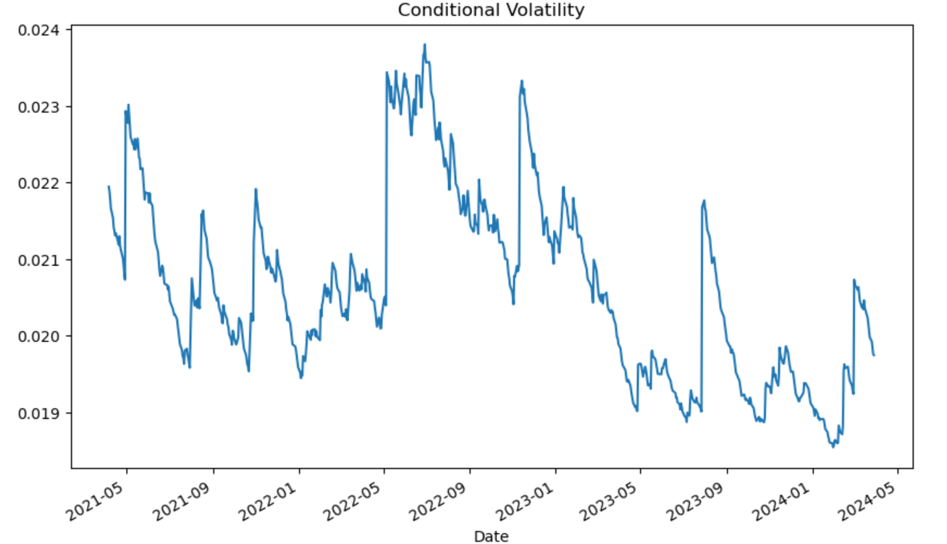

The graph depicts the conditional volatility of a time series over a period from approximately May 2021 to May 2024. Conditional volatility, as modeled by the GARCH process, captures the changing variability or risk of the returns over time, reflecting periods of higher and lower market uncertainty.

From the graph, we observe that volatility is not constant; it fluctuates significantly over the given period. This pattern is typical in financial time series data, where volatility clusters — periods of high volatility tend to be followed by high volatility, and periods of low volatility tend to be followed by low volatility. Here are some key observations from the plot:

**Initial High Volatility (May 2021):**

The graph starts with relatively high volatility around May 2021. This could be due to market reactions to certain events or general market conditions during that period.

**Decline in Volatility (Mid to Late 2021):**

Following the initial high volatility, there is a noticeable decline leading into late 2021. This period may reflect a stabilization phase in the markets where uncertainties or risks were perceived to be lower.

**Spikes in Volatility (2022):**

Throughout 2022, there are several spikes in volatility, indicating periods of increased market uncertainty or significant events impacting the market. These spikes show the markets reacting to various external shocks, whether economic data releases, geopolitical events, or other factors.

**Relative Stability with Occasional Spikes (2023):**

Moving into 2023, while the overall trend appears to be relatively stable, there are still occasional sharp increases in volatility. This suggests that while the market had periods of calm, it was still susceptible to sudden shocks.

**End Period Low Volatility (Early 2024):**

In early 2024, the volatility decreases significantly, reaching one of the lowest points in the observed period. This might indicate a period of relative market stability and confidence.

**Final Spike (Mid 2024):**

Just before the end of the observed period, there is a notable spike in volatility again. This indicates that, despite overall stability, markets remain sensitive to new information or events that can suddenly increase uncertainty.

The graph highlights the dynamic nature of financial markets where volatility is subject to rapid changes in response to new information or external events. The periods of high volatility likely correspond to times of economic uncertainty, significant news, or geopolitical events that impact investor sentiment. Conversely, periods of low volatility suggest more stable market conditions where risks are perceived to be lower.

Overall, the GARCH model effectively captures these volatility patterns, providing insights into the underlying risk dynamics of the time series data over the observed period.

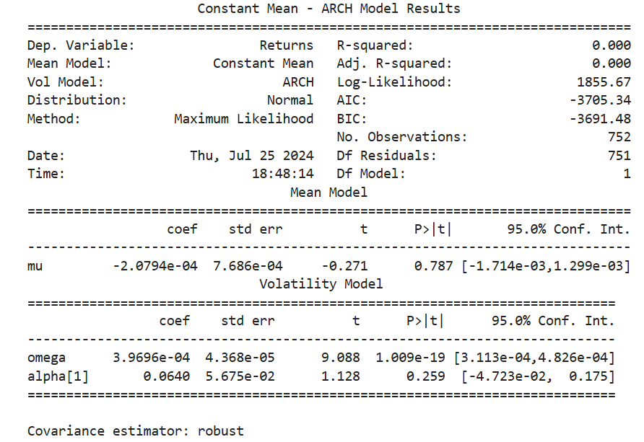

The output from an ARCH (Autoregressive Conditional Heteroskedasticity) model, is used to model and forecast the variance (volatility) in time-series data, particularly financial returns. The analysis starts with general information about the model setup, which indicates that the dependent variable is returns, modeled with a constant mean and volatility modeled using the ARCH method. The data is assumed to follow a normal distribution, and the model parameters were estimated using the Maximum Likelihood method. The dataset consists of 752 observations.

The model fit statistics include an R-squared and adjusted R-squared of 0.000, indicating that the mean model explains none of the variance in the returns, which is typical for models focused on volatility. The log-likelihood value is 1855.67, and the information criteria (AIC and BIC) values are -3705.34 and -3691.48, respectively. These criteria help in comparing models, with lower values generally indicating a better fit.

Examining the mean model results, the estimated mean return (mu) is -2.0794e-04. This value is close to zero, suggesting that the average return over the period is effectively zero. The t-value for mu is -0.271, and the associated P-value is 0.787, indicating that the mean return is not statistically significant. This implies that the mean return does not deviate significantly from zero, a common finding in financial return series.

Turning to the volatility model results, the constant term (omega) in the variance equation is 3.9696e-04 with a very low standard error, indicating high precision in the estimate. The t-value for omega is 9.088, and the P-value is 1.009e-19, confirming that omega is highly significant. This parameter represents the baseline level of volatility in the data. However, the parameter alpha[1], which measures the short-term impact of past return shocks on current volatility, is 0.0640 with a t-value of 1.128 and a P-value of 0.259. This indicates that alpha[1] is not statistically significant, as its 95% confidence interval includes zero.

In summary, the mean return is not significantly different from zero, and the volatility model captures a significant baseline level of volatility. However, the ARCH effect, represented by alpha[1], is not significant, suggesting that past return shocks do not have a strong impact on current volatility in this dataset. The model fit statistics suggest that while the ARCH model provides some insight, a more complex model like GARCH might be necessary to better capture the volatility dynamics in the data.

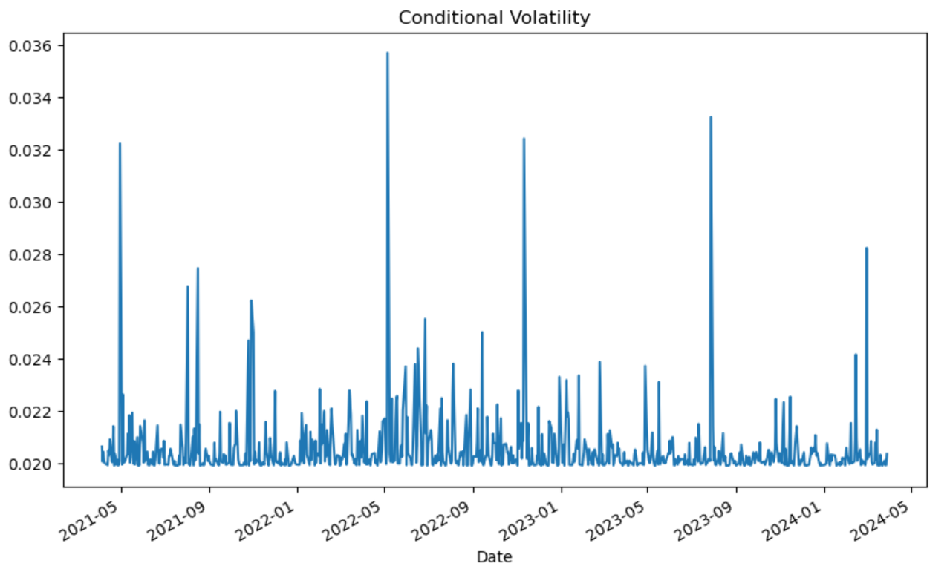

The graph depicts the conditional volatility of a time series over a period from approximately May 2021 to May 2024. Conditional volatility, as modeled by the ARCH process, captures the changing variability or risk of the returns over time, reflecting periods of higher and lower market uncertainty. Some of the Key Observations are:

**High Initial Volatility (May 2021):**

The graph starts with relatively high volatility around May 2021. This suggests a period of significant market fluctuations or high uncertainty during that time.

**Frequent Spikes in Volatility:**

Throughout the entire period, there are multiple sharp spikes in volatility. These spikes indicate sudden increases in market uncertainty or significant events impacting the market. For example, there are prominent spikes around mid-2021, early 2022, mid-2022, and late 2023.

**Periods of Lower Volatility:**

Between these spikes, the volatility often returns to lower levels, showing that the market experienced periods of relative calm or stability. Despite the recurring spikes, the baseline volatility remains relatively low, around 0.020.

**Volatility Clustering:**

There is evidence of volatility clustering, where high volatility periods are followed by more high volatility and low volatility periods are followed by low volatility. This clustering is typical in financial markets, reflecting persistent periods of turbulence or tranquility.

**Significant Spikes:**

The most significant spikes in volatility occur around late 2021, mid-2022, early 2023, and again in mid-2024. These extreme values indicate significant events or shocks impacting the market, causing rapid increases in risk.

The plot demonstrates the dynamic nature of financial market volatility over the observed period. The frequent and pronounced spikes in conditional volatility suggest that the market was subject to various shocks and periods of high uncertainty. Each spike likely corresponds to specific events or news that significantly impacted investor sentiment, such as economic reports, geopolitical events, or other major occurrences.

The periods of lower volatility indicate phases where the market was relatively stable, and risks were perceived to be lower. However, the recurring spikes highlight the market's sensitivity to new information and its rapid adjustment to perceived risks.

Overall, the ARCH model effectively captures the fluctuations in market volatility, providing valuable insights into the underlying risk dynamics over time. This information can be crucial for developing strategies to mitigate potential risks and capitalize on periods of market stability.

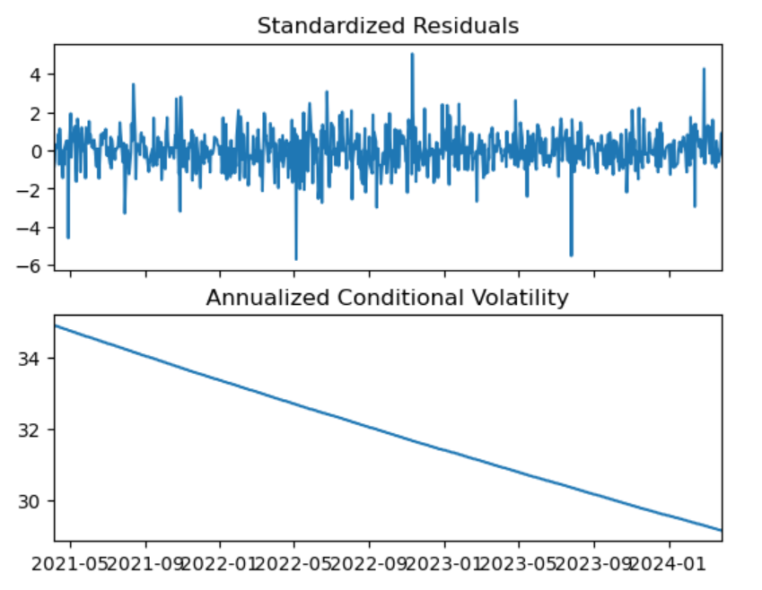

**Standardized Residuals:**The top plot shows the standardized residuals over time. Standardized residuals are the residuals (errors) from the model, scaled by their estimated standard deviation. These residuals help assess the adequacy of the model by highlighting periods of poor fit or remaining autocorrelation in the data.

Key Observations:

Centering Around Zero: The residuals are centered around zero, which is a good indication that the model captures the mean of the returns well.

Variance Consistency: The variability of the residuals appears relatively consistent over time, with most residuals falling within the range of -2 to 2. However, there are some notable spikes beyond this range, indicating periods of unusually high or low returns not fully captured by the model.

Outliers: There are a few significant outliers, such as the spike around 4 and the dip around -6. These outliers may correspond to extreme market events or shocks.

No Apparent Patterns: There are no obvious patterns or autocorrelation in the residuals, suggesting that the ARCH model has effectively captured the time-varying volatility in the data.

**Annualized Conditional Volatility:**

The bottom plot shows the annualized conditional volatility over time. This metric provides a sense of the changing risk levels in the time series on an annualized basis.

Key Observations:

Downward Trend: The plot shows a clear downward trend in volatility over the observed period from May 2021 to early 2024. This indicates that the overall market risk has been decreasing over time.

Volatility Magnitude: The values start around 34% annualized volatility and decrease to just below 30% by the end of the period. This range indicates a high level of initial market uncertainty that gradually stabilizes.

Stability in Decline: The decline appears smooth and continuous, suggesting a gradual stabilization rather than abrupt changes in market risk.

Interpretation:

The combined interpretation of both plots provides a comprehensive view of the time series characteristics and model performance. The standardized residuals indicate that the ARCH model is capturing the mean behavior of the returns well, with most residuals staying within a reasonable range around zero. However, the presence of outliers suggests that there are occasional extreme events or shocks that the model might not fully capture.

The annualized conditional volatility plot shows a significant downward trend in market risk over the observed period. This could be indicative of a period of market stabilization, reduced uncertainty, or an overall calming of market conditions. The smooth decline in volatility suggests that there are no sudden changes in market sentiment, aligning with a period of decreasing uncertainty.

Overall, these plots provide valuable insights into the performance of the ARCH model and the underlying time series dynamics. The model appears to effectively capture the general volatility trends and the consistency of the residuals indicates a good fit, although occasional outliers remind us of the inherent unpredictability in financial markets. This information is crucial for investors and risk managers to understand market behavior and make informed decisions based on the changing risk landscape.

# Part B – VAR and VECM

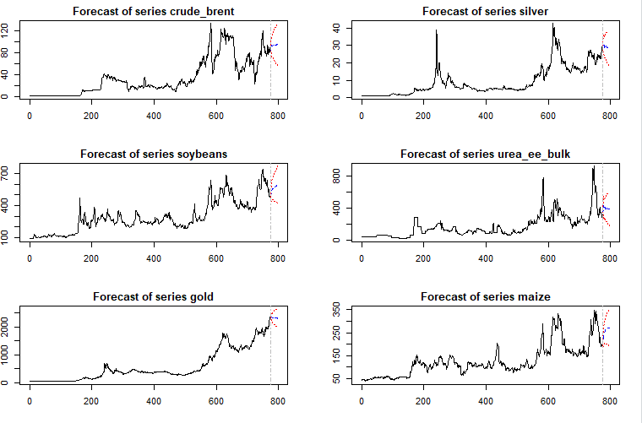

The six plots illustrate the forecasts for different series: crude_brent, silver, soybeans, urea_ee_bulk, gold, and maize. On each plot, the x-axis indicates time, possibly measured in days or months, while the y-axis shows the value of the respective series, which varies notably across the different plots.

**Features**

All the series demonstrate upward trends over time, though the degree of volatility varies. The values exhibit significant fluctuations, characterized by periods of rapid increases and decreases. Each plot features a vertical line near the right edge, the significance of which is unclear without further context.

**Individual Series Analysis**

Crude Brent:  
The series begins at a low value and shows substantial growth accompanied by fluctuations. It reaches a peak and then appears to stabilize.

Silver:  
Starting at a low value, silver exhibits steady growth with some fluctuations. The trend seems to accelerate towards the end.

Soybeans:  
This series starts at a relatively high value and undergoes significant fluctuations. There is a noticeable dip followed by a recovery.

Urea_ee_bulk:  
Beginning at a low value, this series shows a consistent upward trend with some fluctuations. The upward trend appears to accelerate towards the end.

Gold:  
Gold starts at a low value and displays a strong upward trend with some fluctuations. The growth seems to accelerate towards the end.

Maize:  
Maize starts at a low value and exhibits a steady upward trend with some fluctuations. The trend appears to accelerate towards the end.

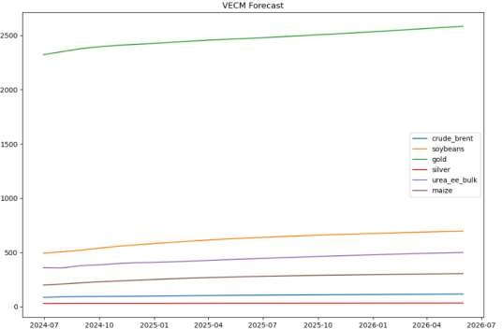

VECM (Vector Error Correction Model) forecast for six commodities: crude brent, soybeans, gold, silver, urea_ee_bulk, and maize. A VECM is a statistical model used to analyze multiple time series that are cointegrated, meaning they have a long-term relationship.

**Interpretation:**

Trend Analysis:

All commodities exhibit an upward trend over the forecast period, indicating that their values are expected to increase steadily over time. The consistent upward movement across all series suggests a general positive outlook for these commodities.

Growth Comparison:

The extent of growth varies among the commodities are:

Crude Brent: Shows the highest values throughout the forecast period, indicating strong and sustained growth. The trend line for crude_brent remains consistently above all other commodities, peaking significantly higher.

Soybeans, Gold, Silver, Urea_ee_bulk, and Maize: All display upward trends, but at lower magnitudes compared to crude_brent. Among these, soybeans and gold have relatively higher forecasted values, followed by silver, urea_ee_bulk, and maize, which are clustered closer together.

Individual Series Insights:

Crude Brent:

This commodity starts at a high value around mid-2024 and continues to rise steadily, maintaining a clear lead over the other commodities. The forecast suggests that crude_brent will remain a high-value commodity through to mid-2026.

Soybeans:

Soybeans exhibit a steady upward trend, showing moderate growth over the forecast period. The values start lower compared to crude_brent but indicate a consistent increase, suggesting a positive outlook.

Gold:

Gold also shows a steady upward trend, reflecting increasing values over time. The forecast indicates strong growth, positioning gold as a valuable commodity in the future.

Silver:

Silver starts at a lower value than gold and soybeans but demonstrates a clear upward trajectory. The growth is moderate, suggesting a stable increase in value.

Urea_ee_bulk:

This commodity shows a consistent upward trend, with values starting relatively low and rising steadily. The trend suggests a gradual but steady increase in value.

Maize:

Maize exhibits the lowest starting value among the commodities but follows an upward trend similar to urea_ee_bulk. The forecast indicates steady growth, positioning maize as a commodity with a positive growth outlook.

Overall, the VECM forecast plot illustrates a positive growth trend for all six commodities, with varying degrees of increase. Crude_brent stands out with the highest values and strongest growth, while the other commodities, particularly soybeans, gold, and silver, also show promising upward trends. Urea_ee_bulk and maize, though starting from lower values, exhibit steady growth, indicating a generally optimistic forecast for these commodities over the next two years. This information is valuable for stakeholders in these markets, offering insights into future price movements and potential investment opportunities.

**Recommendations for Risk Management:**

Portfolio Optimization:  
Investors can use the volatility forecasts derived from ARCH/GARCH models to fine-tune their portfolios. By allocating less to assets with higher predicted volatility, investors can manage risk more effectively. This approach ensures that the overall portfolio risk is minimized while potentially enhancing returns from more stable assets.

Value-at-Risk (VaR):  
Volatility forecasts are instrumental in calculating Value-at-Risk (VaR), a metric that quantifies potential portfolio losses at a given confidence level. Understanding VaR helps investors set risk limits and make informed decisions about how much risk they are willing to take. This quantitative measure is crucial for maintaining a balanced risk-reward profile in the portfolio.

Hedging Strategies:  
If the analysis indicates a potential increase in volatility for specific commodities, investors might consider hedging strategies to protect against possible losses. Hedging can involve various techniques such as futures contracts, options, or other financial derivatives. These strategies provide a safety net, ensuring that adverse price movements do not significantly impact the portfolio.

**Recommendations for Investment Decisions:**

Investment Timing:  
The VECM model forecasts can guide investors on the best times to enter or exit investments in the analyzed commodities. By identifying periods of potential growth or decline, investors can optimize their investment timing, capitalizing on favorable market conditions and avoiding downturns.

Commodity Selection:  
The analysis helps investors identify commodities with high growth potential and lower volatility based on ARCH/GARCH model forecasts. This informed selection process allows investors to focus on commodities that are likely to yield better returns while minimizing exposure to high-risk assets.  
  
In summary, incorporating volatility forecasts into risk management and investment decisions enhances the ability to manage risks and capitalize on growth opportunities. Combining quantitative analysis with fundamental factors and diversification ensures a robust approach to investing in commodities.

**CODES**

**The codes are in GitHub link :**

**<https://github.com/UJWAL1529>**